
Hkkjrh; izkS|ksfxdh LkaLFkku iVuk
Indian Institute of Technology Patna
Department of Electrical Engineering
IIT Patna, Campus, Bihta, Patna, Bihar – 801103 Experiment- 7

VOLTAGE TO FREQUENCY CONVERTER

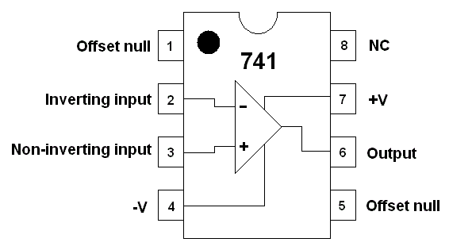
OBJECTIVE: Designing a voltage to frequency converter.
COMPONENTS REQUIRED

:

Op-Amp : Two LM741.
Transistor : One 2N2222A
Diode : one 6.2V zener diode.
Resistance : One 330, One 1kΩ, two
2.2KΩ, one 3.9KΩ, one 5.6KΩ,
two 10 kΩ, three 100 kΩ.
: Capacitor : One 10 µF.

PRECAUTIONS AND GUIDELINES Fig 7.1

1. The op-amp (Fig 7.1) generally works on split power supply (e.g. ±12 V). Both positive and negative power supplies must be present whenever op-amp is powered. The range of power supply is from ±5 V to ±15 V. Do not forget to connect the common terminal of the power supply to the ground on the breadboard.

2. Connecting only one side of power supply or interchanging positive and negative power supplies damages the op-amp.

3. While switching on the set-up, switch on the oscilloscope first, then the power supply to the circuit, and finally the function generator. When switching off, follow the sequence in reverse order.
4. For any IC, never exceed the input voltage beyond the power supply limits.

5. Keep ground terminals of the oscilloscope probes and function generator output, and power supply common connected together throughout the experiment.

The circuit shown in Fig. 7.2 is of Voltage to Frequency converter

Working Principle: Initially, the capacitor C gets charged at constant rate of (Vi / R3) amp. The output voltage Va at point ‘a’ drops linearly till this voltage is not less than the voltage Vb at point ‘b’ which is approx. at about -5.0V. Note that, the comparator output voltage VC is at approx. -12V when Va is greater than -5.0V and the transistor is in ‘off’ state.

When the negatively increasing voltage Va becomes less than -5.0V, the comparator output Vc goes to approx. +12V. The transistor gets ‘on’ and hence the emitter voltage (also voltage at comparator ‘+’ input) of the transistor is about at zero voltage. The transistor is in saturated state. The capacitor starts discharging. The discharging continues and Va increases positively, till Va becomes greater than zero voltage. The comparator output VC becomes about -12V and the transistor becomes ‘off’. This charging and discharging process repeats again and again. Note that the discharging duration is same for any input voltage Vi and it should be much smaller than the charging time, which depends on the input voltage Vi.

Pre-experiment Reading:

(a) Draw the waveforms at (i) Va (ii) Vb and (iii) Vc
(b) Compute the charging time of the capacitor.
(c) Compute the discharging time of the capacitor.
(Assume Vi= 4V for above)

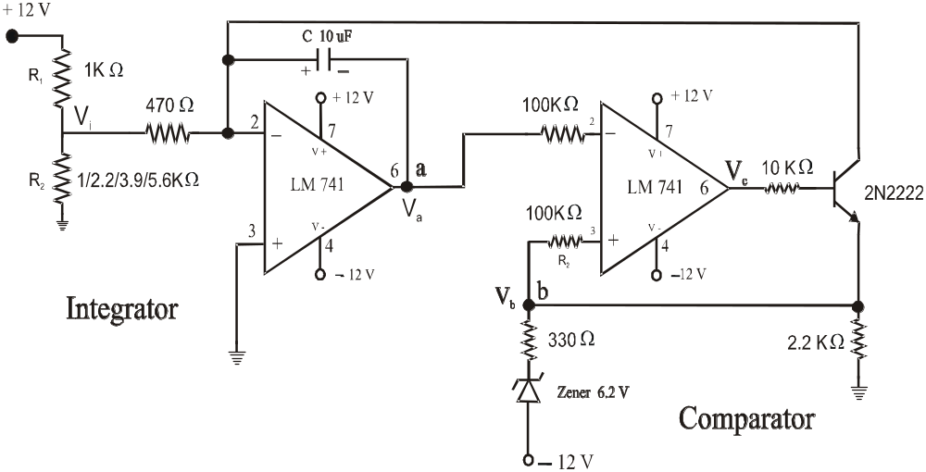

Fig 7.2 Voltage to Frequency Converter

OBSERVATIONS:

1. Connect the circuit as shown in Fig 7.2 with R1 = 1 kΩ, and R2 = 1 kΩ. Make sure the power supply ground is connected to the circuit ground.
2. Observe the waveform Va at point ‘a’ for
(a) for R2 = 1 KΩ
(b) for R2 = 2.2 KΩ
(c) for R2 = 3.9 KΩ
(d) for R2 = 5.6 KΩ
and measure frequency form the output at point (Vc)
3. Similarly, observe the waveform Vb at point ‘b’ for all Vi as in step 2.

4. Remove the zener diode and replace it by a resistance so that Vb is approx. at -5.0V and observe Vb (both frequency and pulse width).

----------------------------

